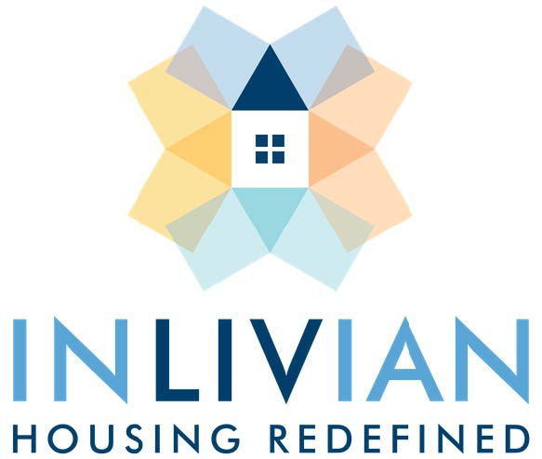

NOTICE

Board Meeting

August 17, 2021

Notice is hereby given that the Regular Board Meeting
will be held via teleconference with the
Commissioners of INLIVIAN Tuesday, August 17, 2021
beginning at 5:30 p.m. For those interested in providing Public Comment,
please contact Stacy Bridges at (704) 336-5221 or sbridges@INLIVIAN.com to register in advance.

A. Fulton Meachem, Jr.
President/CEO

Mission Statement:

“To create innovative housing solutions in desirable communities for residents of diverse incomes and facilitate access to services to help them succeed.”
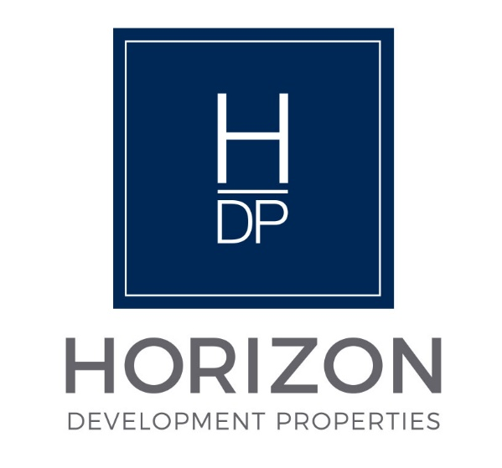
NOTICE

Regular Board Meeting
Board of Directors

August 17, 2021

Notice is hereby given that the Regular Board Meeting will be held via teleconference with the Board of Directors of Horizon Development Properties, Inc.
on Tuesday, August 17, 2021 as follows:

Time/Date: Immediately following the INLIVIAN Regular Board
meeting which convenes at 5:30pm August 17, 2021.

For more information, please contact Stacy Bridges at
(704) 336-5221 or sbridges@INLIVIAN.com.

A. Fulton Meachem, Jr.
President/CEO

