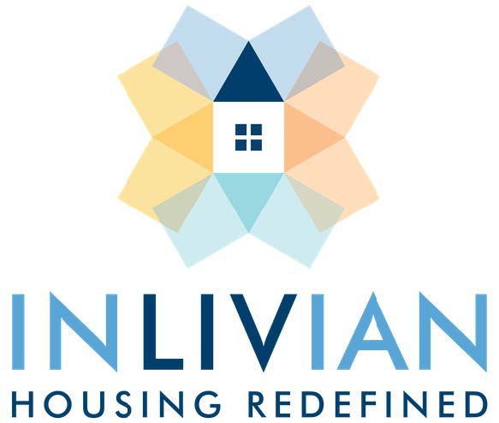

NOTICE

Board Meeting

May 17, 2022

Notice is hereby given that a Regular Board Meeting
will be held via teleconference with the Commissioners of INLIVIAN
Tuesday, May 17, 2022 beginning at 5:30 p.m.

A. Fulton Meachem, Jr.
President/CEO

Mission Statement:
“To create innovative housing solutions in desirable communities for residents of diverse incomes and facilitate access to services to help them succeed.”

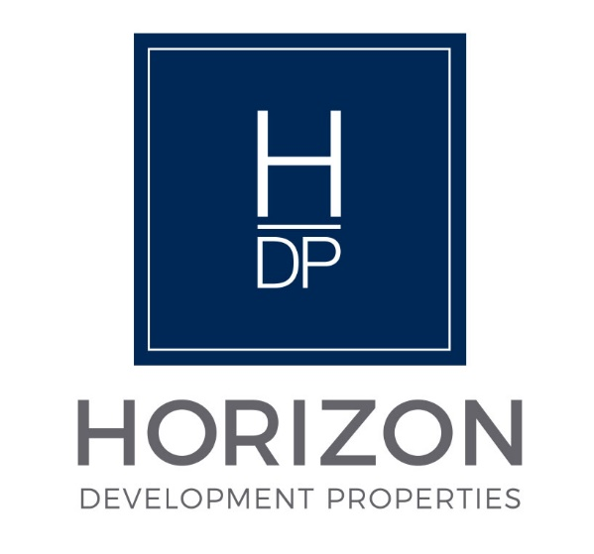
NOTICE

Regular Board Meeting
Board of Directors

May 17, 2022

Notice is hereby given that the Regular Board Meeting will be held via teleconference with the Board of Directors of Horizon Development Properties, Inc.
on Tuesday, May 17, 2022, as follows:

Time/Date: Immediately following the INLIVIAN Regular Board
Meeting which convenes at 5:30pm on
May 17, 2022.

A. Fulton Meachem, Jr.
President/CEO
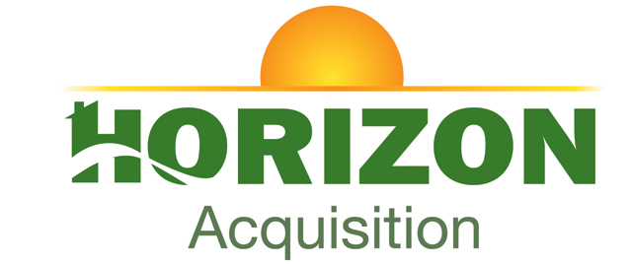

NOTICE

Regular Board Meeting
Board of Directors

May 17, 2022

Notice is hereby given that the Regular Board Meeting will be held with via teleconference the Board of Directors of Horizon Acquisition Corporation on
Tuesday, May 17, 2022, as follows:

Time/Date: Immediately following the INLIVIAN Regular Board
Meeting and Horizon Development Properties, Inc. Board of Directors meeting which convenes at 5:30pm
May 17, 2022.

A. Fulton Meachem, Jr.
President/CEO

