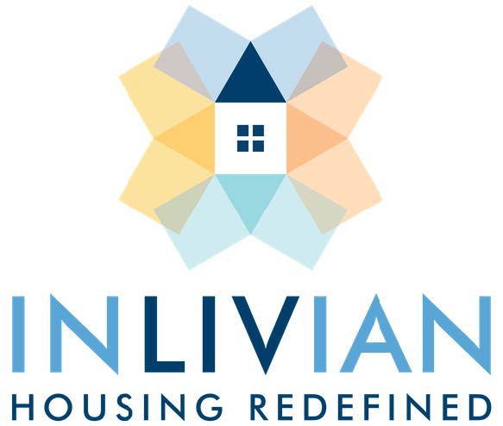

NOTICE

Special Board Meeting

December 14, 2022

Notice is hereby given that a Special Board Meeting
will be held with the Commissioners of INLIVIAN
Tuesday, December 14, 2022, beginning at 6:00 p.m.

A. Fulton Meachem, Jr.
President/CEO

Mission Statement:
“To create innovative housing solutions in desirable communities for residents of diverse incomes and facilitate access to services to help them succeed.”

