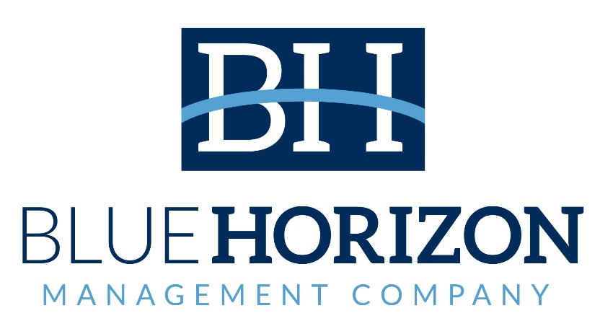

**NOTICE**

**Regular Board Meeting**

**Board of Directors**

**December 19, 2023**

**Notice** is hereby given that the Regular Board Meeting will be held with the Board of Directors of Blue Horizon Management Company on

**Tuesday, December 19, 2023,** as follows:

**Time/Date:** Immediately following the INLIVIAN, Horizon

Development Properties, Inc., Horizon Acquisition

Corporation Regular Board meetings, which convenes at

5:30 pm December 19, 2023.

**A. Fulton Meachem, Jr.**

**President/CEO**