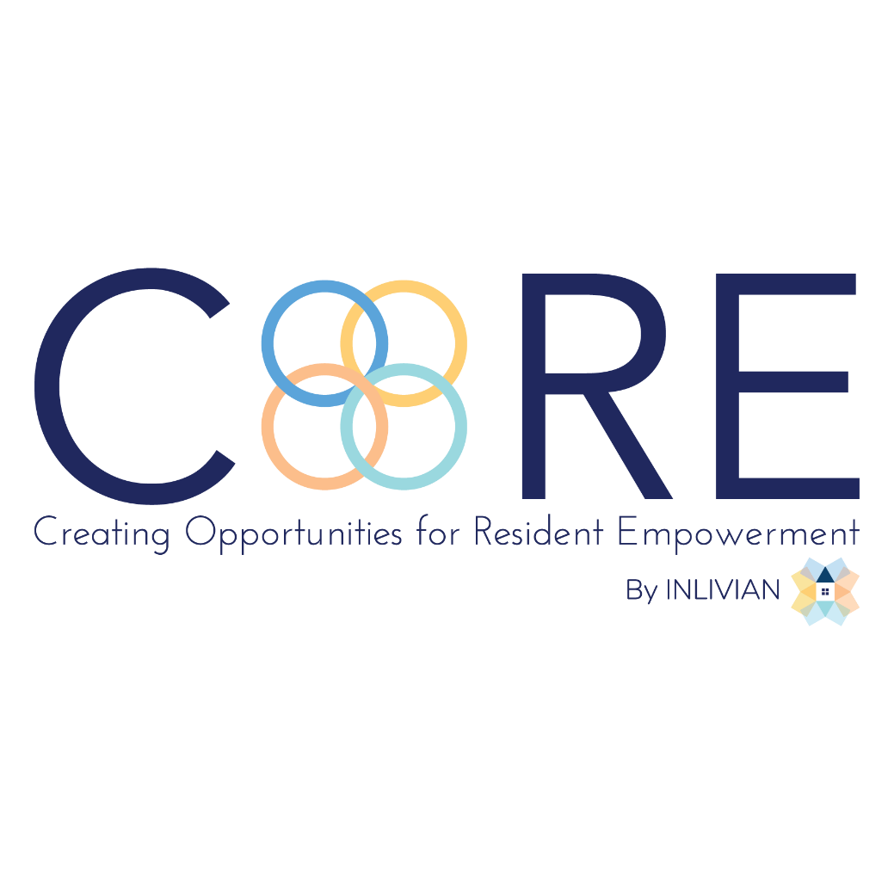
NOTICE

Regular Board Meeting
Board of Directors

December 19, 2023

Notice is hereby given that the Regular Board Meeting
will be held with the Board of Directors of C.O.R.E. Programs, Inc. on
Tuesday, December 19, 2023, as follows:

Time/Date: Immediately following the INLIVIAN, Horizon
Development Properties, Inc, Horizon Acquisition Corporation and Blue Horizon Management Company Regular Board meetings which convene at 5:30 pm December 19, 2023.



A. Fulton Meachem, Jr.
President/CEO

