**NOTICE**

**Regular Board Meeting**

**Board of Directors**

**December 19, 2023**

**Notice** is hereby given that the Regular Board Meeting will be held with

the Board of Directors of Horizon Acquisition Corporation on

**Tuesday, December 19, 2023,** as follows:

**Time/Date:** Immediately following the INLIVIAN Regular Board

Meeting and Horizon Development Properties, Inc. Board of Directors meeting, which convenes at 5:30pm

December 19, 2023.

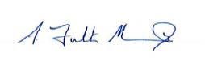

**A. Fulton Meachem, Jr.**

**President/CEO**