**NOTICE**

**Regular Board Meeting**

**Board of Directors**

**November 19, 2024**

**Notice** is hereby given that the Regular Board Meeting will be held with the

Board of Directors of Horizon Development Properties, Inc.

on **Tuesday, November 19, 2024,** as follows:

**Time/Date:** Immediately following the INLIVIAN Regular Board

Meeting, which convenes at 5:30 pm on

November 19, 2024.

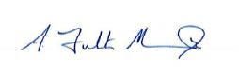

**A. Fulton Meachem, Jr.**

**President/CEO**