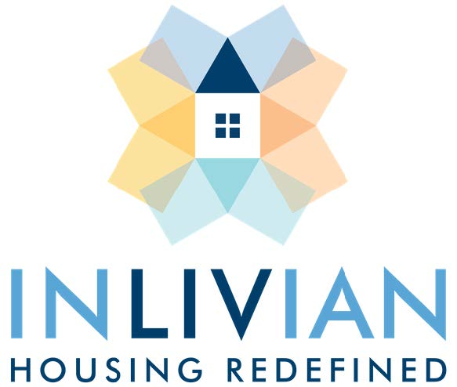

NOTICE

Board Meeting

February 17, 2026

Notice is hereby given that a Regular Board Meeting
will be held with the Commissioners of INLIVIAN
Tuesday, February 17, 2026, beginning at 5:30 p.m.
at 400 East Blvd., Charlotte, NC, and via teleconference.

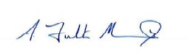

A. Fulton Meachem, Jr.
President/CEO

Mission Statement:
“To create innovative housing solutions in desirable communities for residents of diverse incomes and facilitate access to services to help them succeed.”

