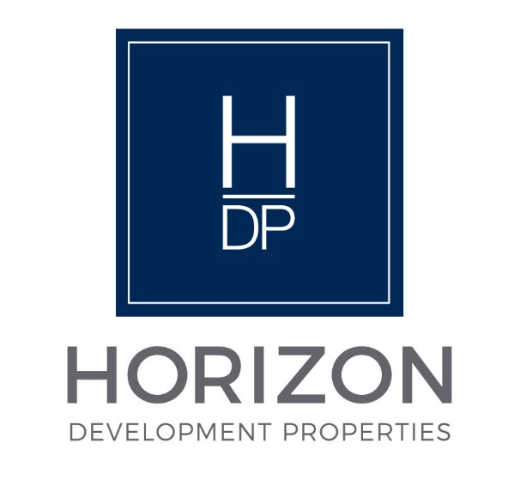
NOTICE

Regular Board Meeting
Board of Directors

April 21, 2026

Notice is hereby given that the Regular Board Meeting will be held with the
Board of Directors of Horizon Development Properties, Inc.
on Tuesday, April 21, 2026, as follows:

Time/Date: Immediately following the INLIVIAN Regular Board
Meeting, which convenes at 5:30 pm on April 21, 2026.

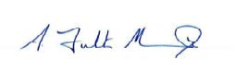

A. Fulton Meachem, Jr.
President/CEO

