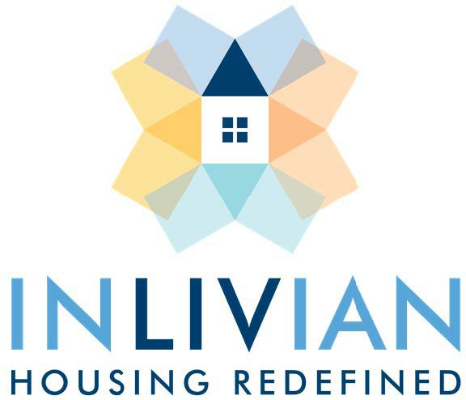

NOTICE

POLICY AND CLIENT RELATIONS COMMITTEE MEETING
FINANCE AND AUDIT COMMITTEE MEETING
REAL ESTATE DEVELOPMENT COMMITTEE MEETING

May 5, 2026

Notice is hereby given that the Commissioners of INLIVIAN will hold their regular monthly Committee Meetings Tuesday, May 5, 2026
beginning at 10:30am, via a hybrid format, through teleconference and
in-person at 400 East Blvd., 2nd Floor Board Room, Charlotte NC 28203

Date/Time: May 5, 2026
10:30am – 4:00pm
A. Fulton Meachem, Jr. President/CEO

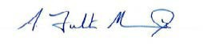
Mission Statement:
“To create innovative housing solutions in desirable communities for residents of diverse incomes and facilitate access to services to help them succeed.”

