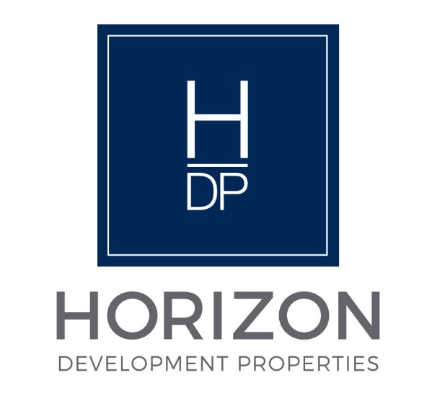
NOTICE

Regular Board Meeting
Board of Directors

May 19, 2026

Notice is hereby given that the Regular Board Meeting will be held with the
Board of Directors of Horizon Development Properties, Inc.
on Tuesday, May 19, 2026, as follows:

Time/Date: Immediately following the INLIVIAN Regular Board
Meeting, which convenes at 5:30 pm on May 19, 2026.



A. Fulton Meachem, Jr.
President/CEO

