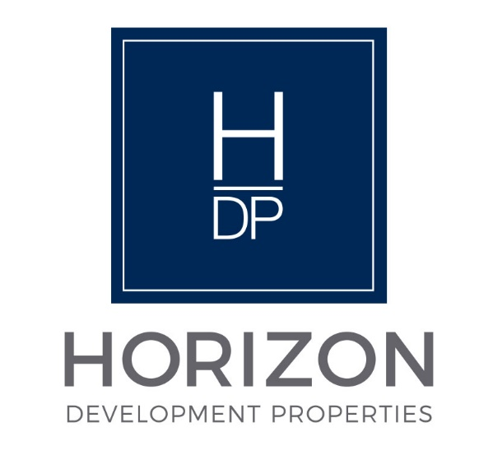
NOTICE

Regular Board Meeting
Board of Directors

June 16, 2026

Notice is hereby given that the Regular Board Meeting will be held with the
Board of Directors of Horizon Development Properties, Inc.
on Tuesday, June 16, 2026, as follows:

Time/Date: Immediately following the INLIVIAN Regular Board
Meeting, which convenes at 5:30 pm on June 16, 2026.



A. Fulton Meachem, Jr.
President/CEO

