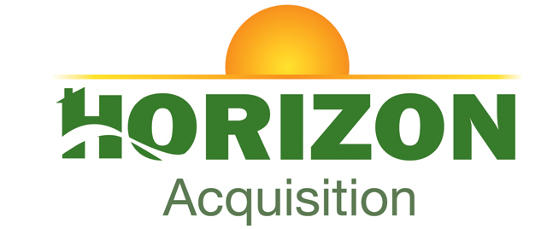

NOTICE

Regular Board Meeting
Board of Directors

October 20, 2026

Notice is hereby given that the Regular Board Meeting will be held with
the Board of Directors of Horizon Acquisition Corporation on
Tuesday, October 20, 2026, as follows:

Time/Date: Immediately following the INLIVIAN Regular Board
Meeting and Horizon Development Properties, Inc. Board of Directors meeting, which convenes at 5:30pm on
October 20, 2026.

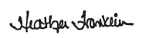

Heather Franklin
Interim President/CEO

